Neacsu Dragos

Group 132

Decisional Processes

Market Share Project



Contents

1. Market Share by Brand for the Watch Industry in 2020 3

2. Deriving the true priority vector 3

3. Factors that influence the market share formation for the derivation of the model 4

4. Derivation of the model 4

5. Estimating the model 5

A. Creating connections 5

B. Pairwise comparisons 5

C. Evaluate the cluster matrix 6

D. Syntethizing the model 6

6. Validation 7

7. Sensitivity analysis 7

# Market Share by Brand for the Watch Industry in 2020

1. ROLEX – 24.9%
2. OMEGA – 8.8%
3. CARTIER WATCHES – 6.7%

(Taken from<https://monochrome-watches.com/top-50-swiss-watch-brands-2020-market-share-sales-editorial/>)

# Deriving the true priority vector

|  |  |
| --- | --- |
| ***Brand*** | ***Sales for the 2020 year - billion CHF*** |
| ROLEX | 7,956 |
| OMEGA | 2,813 |
| CARTIER WATCHES | 2,150 |

Total sum of brand sales = 7,956 + 2,813 + 2,150 = 12,919 billion CHF

(Taken from<https://monochrome-watches.com/top-50-swiss-watch-brands-2020-market-share-sales-editorial/>)

In order to find the true priority vector, we take the initial values and divide each of them by the total sum.

ROLEX = 7,956/12,919 = 0.615

OMEGA = 2,813/12,919 = 0.217

CARTIER WATCHES = 2,150/12,919 = 0.166

|  |  |
| --- | --- |
| ***Brand*** | ***True Priority Vector*** |
| ROLEX | 0.615 |
| OMEGA | 0.217 |
| CARTIER WATCHES | 0.166 |

# Factors that influence the market share formation for the derivation of the model

Alternatives: ROLEX, OMEGA, CARTIER WATCHES

* Design: minimal, luxurious
* Strap quality: leather, stainless steel, precious metals
* Movement: mechanical, automatic, quartz
* Overall construction
* Features: multiple time zones, moon phases, anti-magnetic
* Digital approach
* Image of the brand
* Brand equity
* Frequency
* Celebrity endorsements
* Store location: the luxurious the placing of the shops, the better
* Store design
* Repair services

# Derivation of the model

|  |  |
| --- | --- |
| ***Clusters*** | ***Nodes*** |
| Alternatives | ROLEX  OMEGA  CARTIER WATCHES |
| Product | Design  Strap quality  Movement  Overall construction  Features |
| Marketing | Digital approach  Image of the brand  Celebrity endorsements  Frequency  Brand equity |
| Others | Store location  Store design  Repair services |

# Estimating the model

## Creating connections

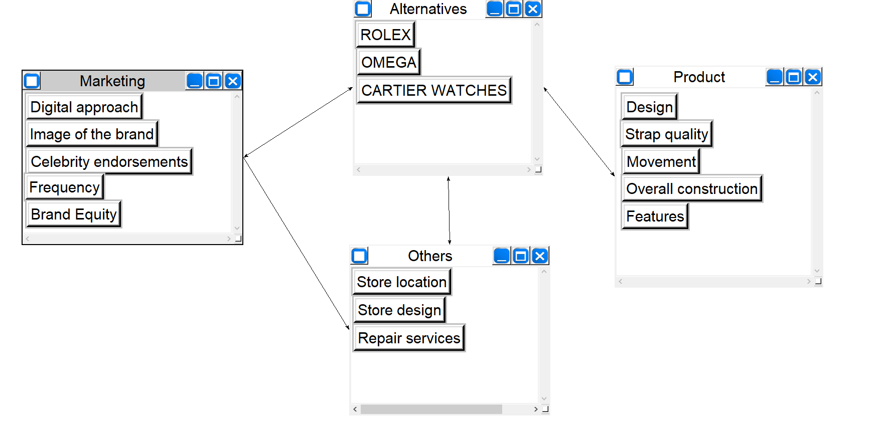

## Pairwise comparisons

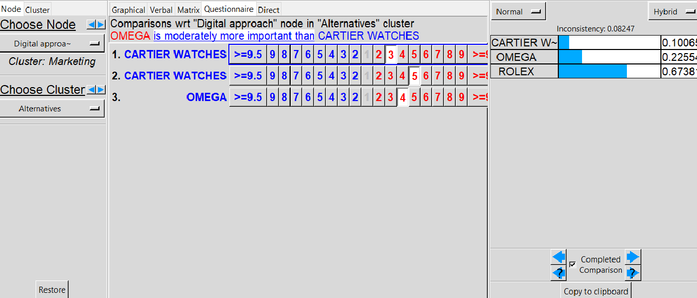

## Evaluate the cluster matrix

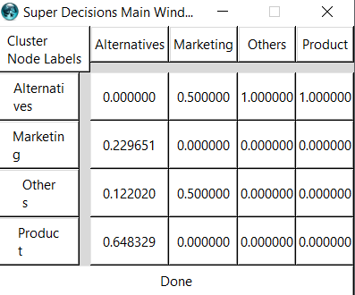

## Syntethizing the model

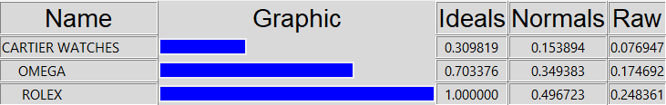

# Validation

We have to check the Compatibility Index to assess if the model is valid or not.

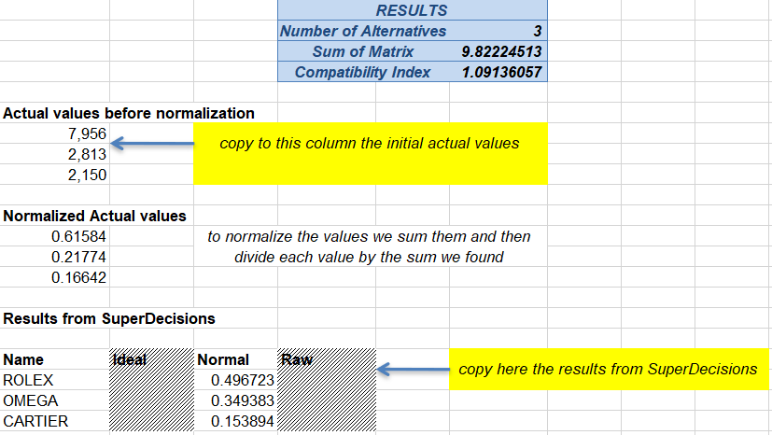

* As we can see in the table above, the value is 1.09 (which is below 1.1)
* All the inconsistency rates are less than 0.1

Thus, we can assume that the model is a valid one.

# Sensitivity analysis

Node sensitivity illustrates how the alternatives’ values change if we put more or less importance on different nodes.

As an example we will talke the „Overall construction” node:

* The brand’s numerical values at the 0.5 parameter (the normal one)

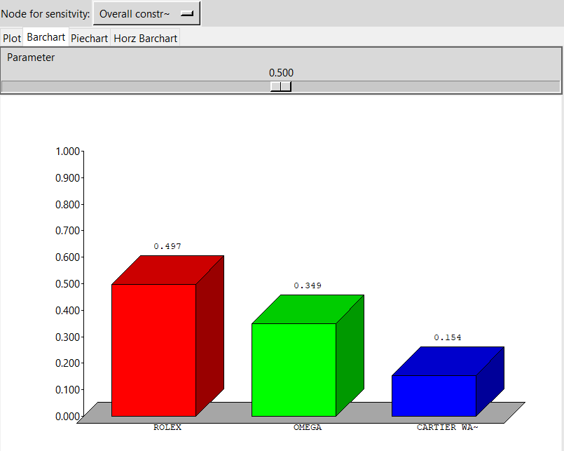

ROLEX: 0.497

OMEGA: 0.349

CARTIER WATCHES: 0.154

* The brand’s numerical values at the 0.75 parameter (+50% more importance)

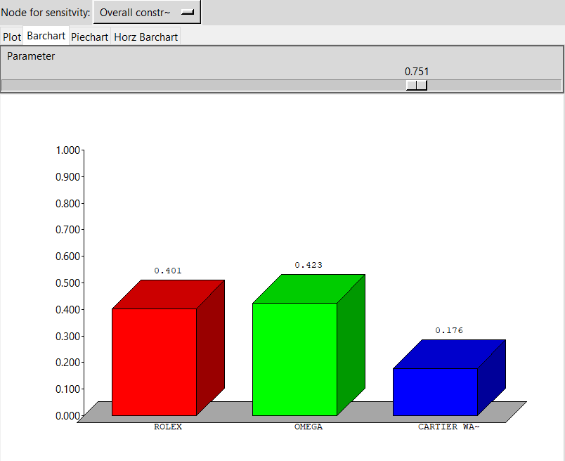

ROLEX: 0.401

OMEGA: 0.423

CARTIER WATCHES: 0.176

* The brand’s numerical values at the 0.25 parameter (-50% more importance)

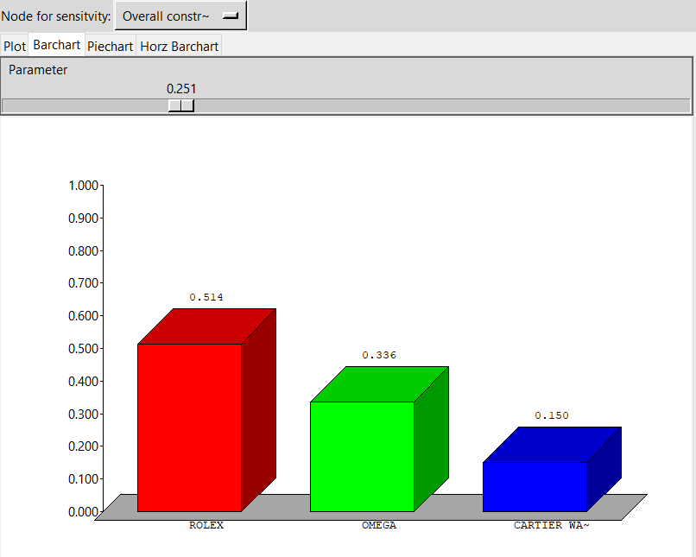

ROLEX: 0.514

OMEGA: 0.336

CARTIER WATCHES: 0.150